Athanasius Joseph Kojo Gadosey
Week 3
Practical Task: The Suspicious Downloaded PCAP Analysis

The following answers are the analysis of the incident reports:

- The IP address of the infected Windows Client is 10.1.17.215
Filter: (ip.src == 10.1.17.0/24 && ip.dst != 10.1.17.0/24) This command was used to analyse the host IP address communicating to any external networks, which helped us to spot the suspicious outbound connections.
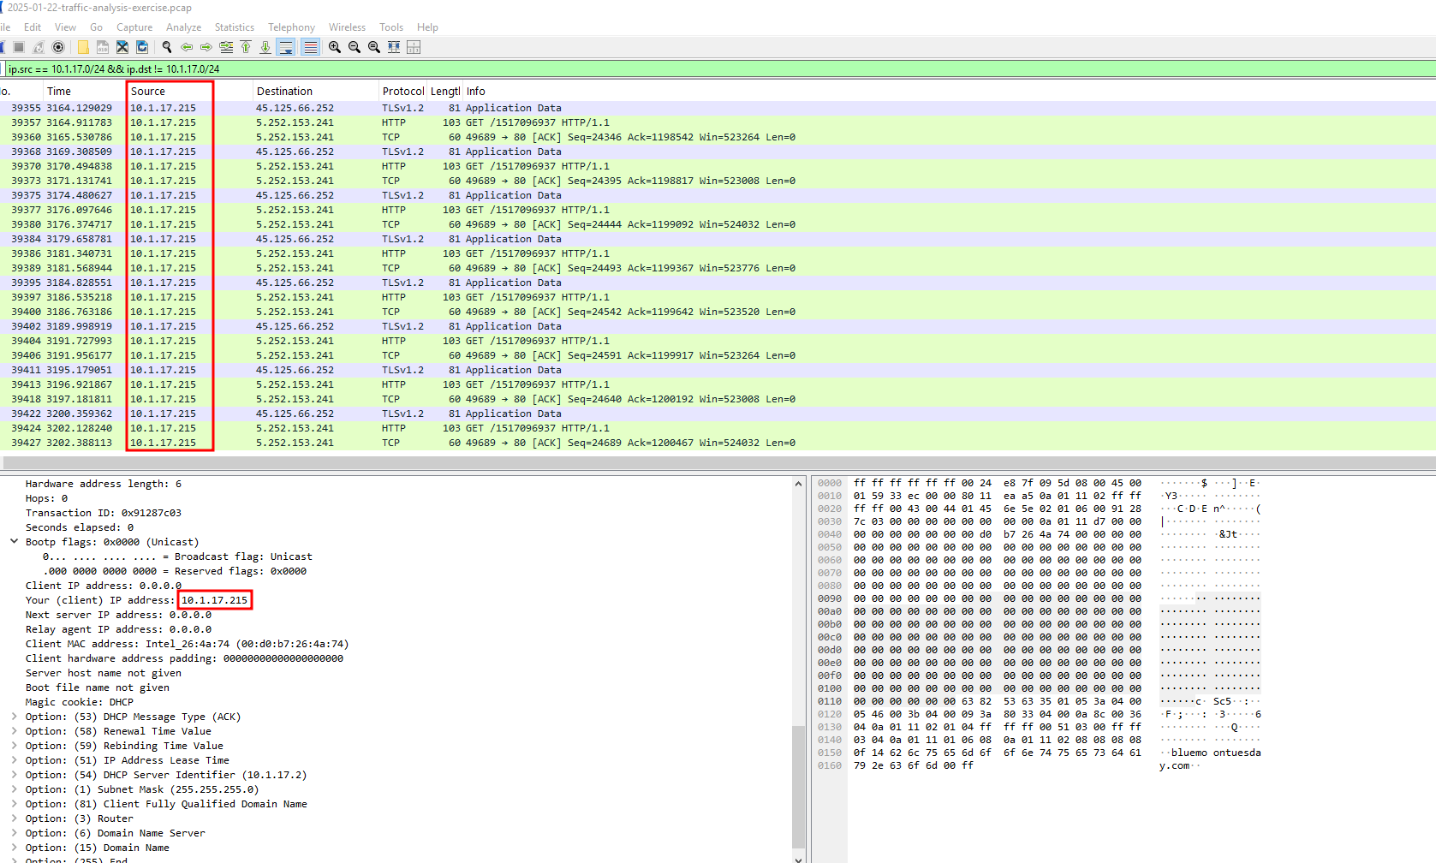

- The MAC address of the infected Windows Client is 00:d0:b7:26:4a:74
Filter: (arp && arp.src.proto_ipv4 == 10.1.17.215 ) This command was to help identify the MAC address of the IP address.
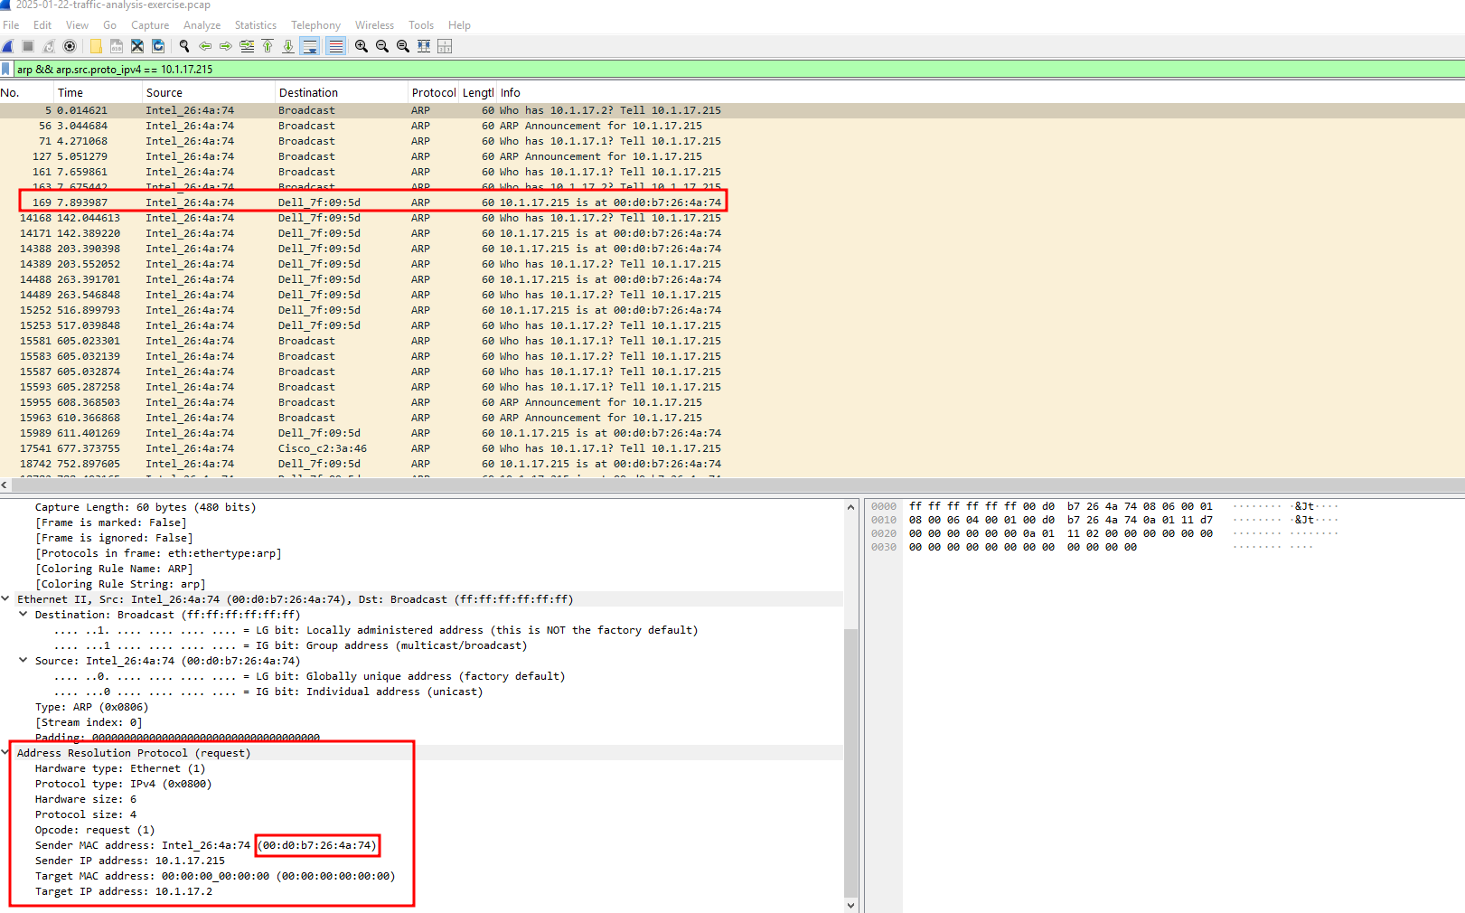

Also, this filter command (eth.addr == 00:d0:b7:26:4a:74) was used to confirm the MAC address of the infected Windows client gotten earlier
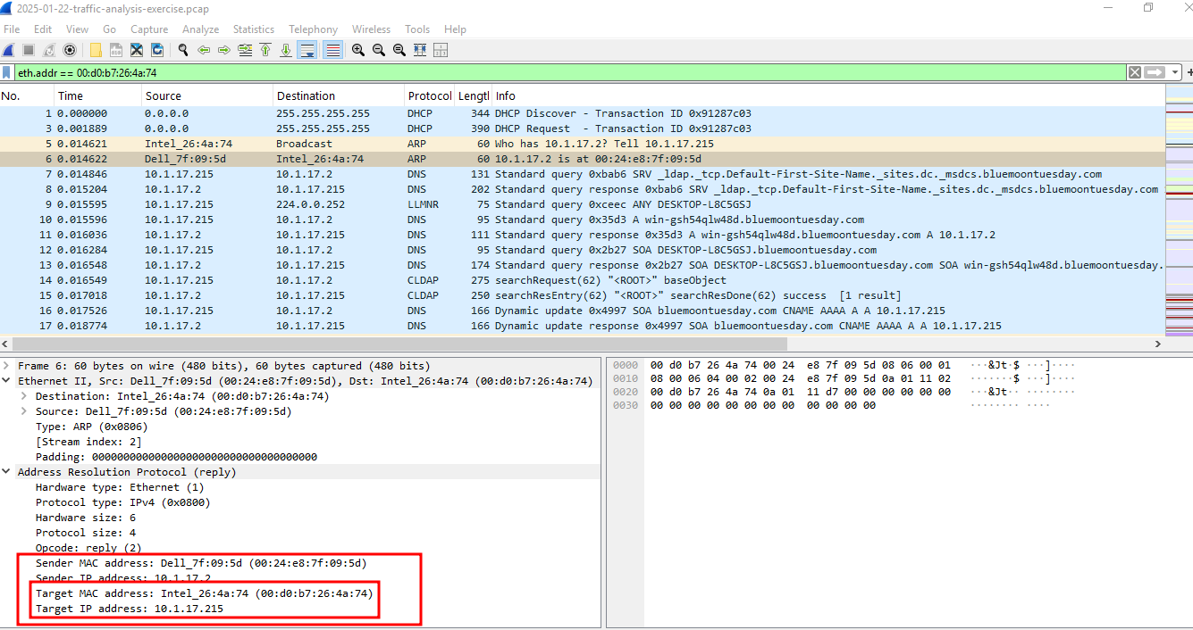

- The hostname of the infected Windows client is www.msfconnecttest.com OR DESKTOP-L8C5GSJ
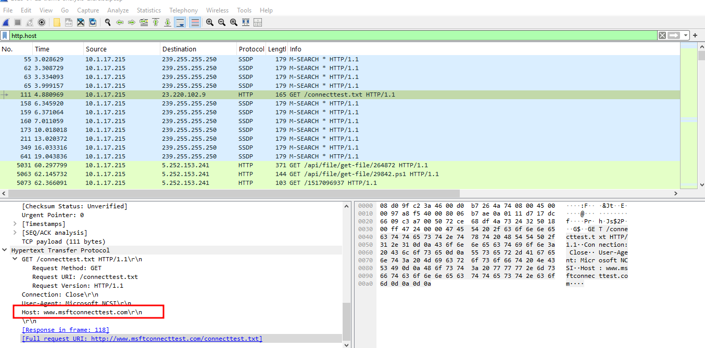

The filter command used is bootp.option.hostname
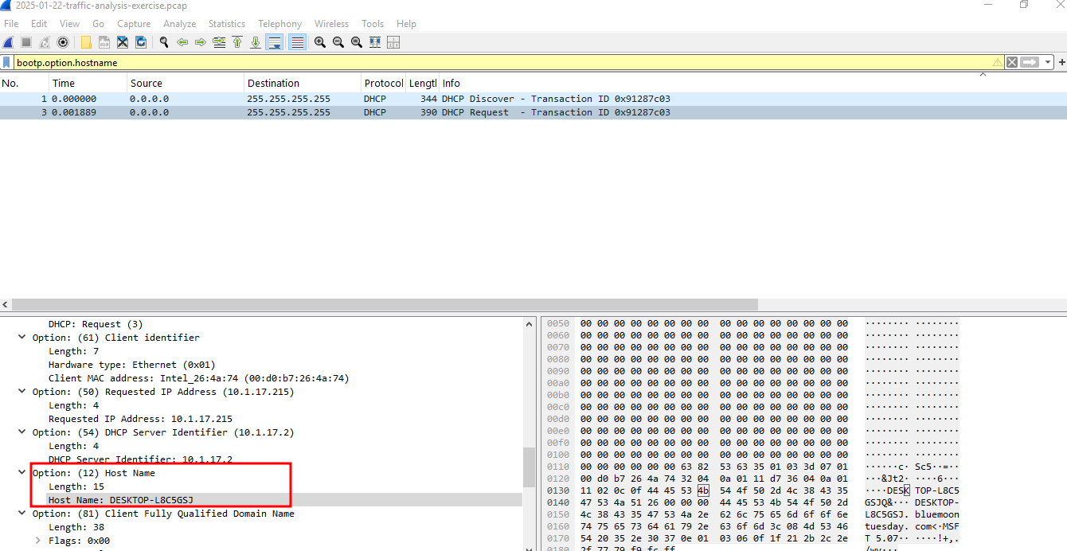

- The user account name from the infected Windows Client is BLUEMOONTUESDAY/shutchenson
Filter: (kerberos.CNameString) This command is used because most user accounts can be found or appear in them, and is also known for its reliability.
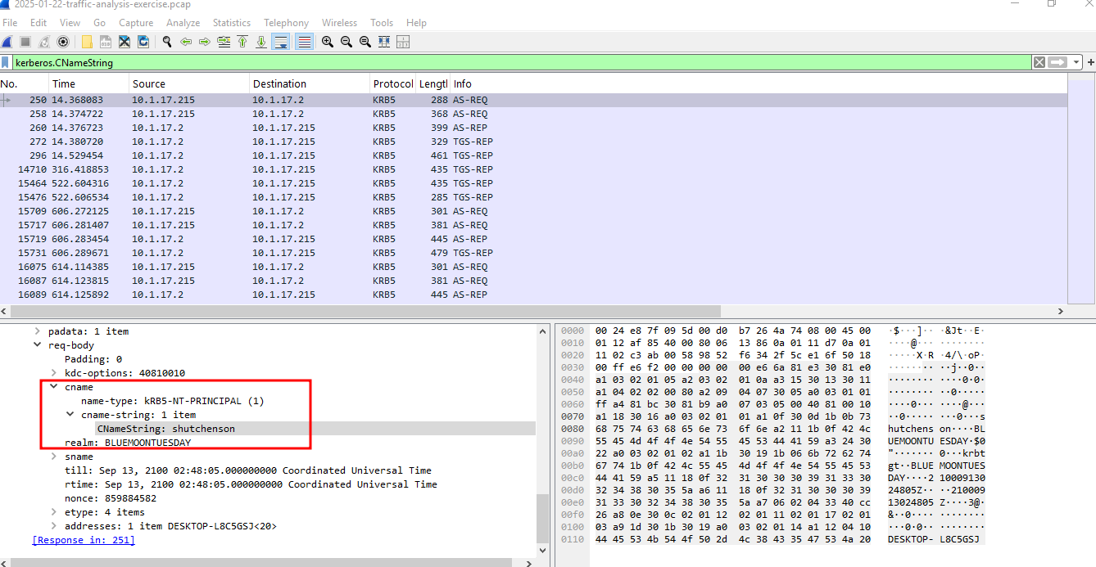

- The likely domain name for the fake Google Authenticator page is authenticatoor.org
Filter: (dns.qry.name contains auth) This command was used to query dns of the infected Windows client.
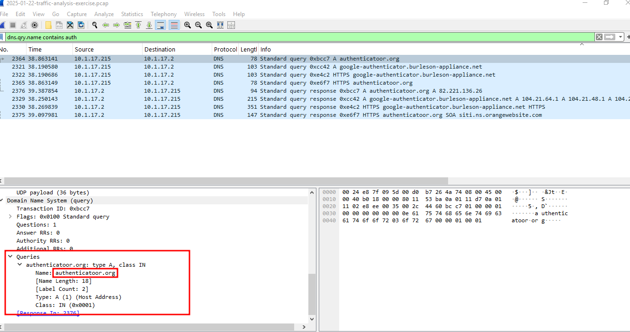

- The IP addresses used for C2 servers for this infection are 5.252.153.241, 45.125.66.252 and 45.125.66.32
Filter for outbound traffic to external IP ranges after the infection.
